Dry Bath Incubator——DH200
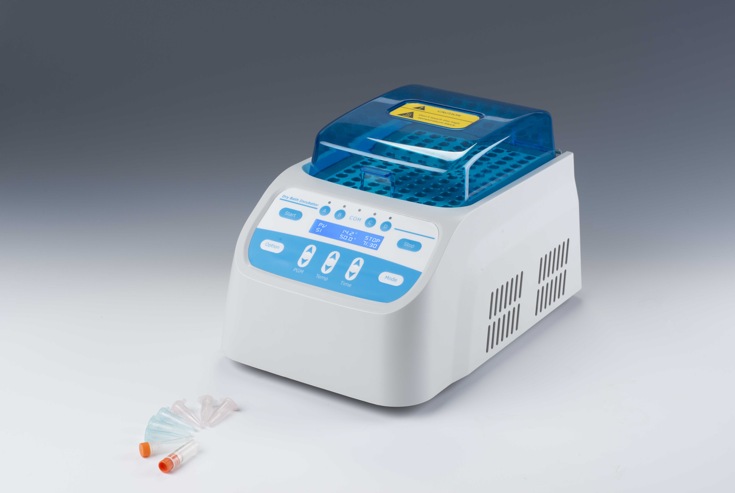
Description:
The Dry Bath Incubator is a microprocessor-controlled dry block heating system with highly precise temperature control, making it an alternative to the traditional water bath devices. It is widely used in the sample preservation, reaction of DNA amplification, electrophoresis, degeneration, solidification and other kinds of serum biochemical sample thermostatic incubation process.

Features:
- LCD display, simple interface. Easy to set up and use.
- Blue transparent lid prevents samples splashing out.
- Accurate temperature control, high stability.
- With four groups(A/B/C/D), timing independently or simultaneously.
- Optional blocks are available for common laboratory tubes and plates.
Custom blocks are also available upon request.
- Automatic preheating function.
- Auto resume to run after power failure.
- Automatic running function.
- Built-in temperature calibration function.
- Built-in over-heating protection device, safe and reliable.

Parameters:
Model | DH200
Temp setting range | 0°C ~110°C
Temp control range | RT+5°C ~110°C
Timing range | 1min ~ 99h59min/∞
Temp accuracy | ≤±0.3°C@37°C*
Display accuracy | 0.1°C
Temp uniformity | ≤±0.3°C@37°C *
Heating time | ≤20min(from 25°C~110°C)
Auto heating | Yes
Auto running | Yes
Auto resume to run | Yes
Timing independently for each group | Yes
Block quantity | 4
Power | 500W
Voltage | AC110V or AC220V/50-60Hz
Fuse | 250V 3A Ф5×20
Dimension(mm) | 370x254x228
Weight(kg) | 8.0

Optional Blocks:
Model | Tube Diameter | Capacity | Model | Diameter | Capacity
MD01 | 6mm | 48 | MD10 | 26mm | 8
MD02 | 7mm | 48 | MD11 | 28mm | 4
MD03 | 10mm | 24 | MD12 | 40mm | 3
MD04 | 12mm | 24 | MD13 | 0.2ml centrifuge tube | 48
MD05 | 13mm | 24 | MD14 | 0.5ml centrifuge tube | 48
MD06 | 15mm | 16 | MD15 | 1.5ml centrifuge tube | 24
MD07 | 16mm | 16 | MD16 | 2.0ml centrifuge tube | 24
MD08 | 19mm | 12 | MD17 | 0.2ml PCR plate | 96
MD09 | 20mm | 12 | MD18 | 0.2ml Elisa plate | 96

